Analysis Document 1

Carrot Quest✅

“Ari”

- Introduction 3-6 pgs
- Overview 4 pgs
- additional task
- project leader
Make sure project is completed within timeframe
schedule work and times for what needs to be in when
Editor: Putting total document together making sure it flows together

“Jimmy”

- Functional requirements 4 pgs ✅
- Nonfunctional requirements 4 pgs ✅
- Additional tasks
  - Creating detailed “mock-up” of the game✅

“Steven & Adan”

(making models & simple bullets
vs. writing descriptions of the models)
https://app.diagrams.net

- System models 2 models 1 written page
- Use case model 3 models 1 written page
- Dynamic models 3 models 2 written pages
- Object and class model 2-4 models 1-2 written pages
- User interface - navigational paths and screen mock-ups 1 image 1 written page
- Additional task
- Bullet description of models for writers to write in detail.

“Jugraj”

- Conclusion 1 page
- Contributions 2 pages
- Glossary & references 1 page
- Additional tasks
- (2nd Editor: Putting total document together making sure it flows together)
Team Effort Check After completion for everyone

Introduction

Overview

Functional and Non-Functional Requirements

Functional Requirements
User Interface (UI)
"Carrot Quest" is designed to have a user-friendly interface that enhances the player's gaming experience. The playful aesthetic, coupled with intuitive navigation, ensures that players can easily interact with the game’s features.
Text and Style
· The game's font is written in 'Bubblegum Sans' to create a fun and inviting atmosphere for the player.
· Bright, engaging color schemes are used to keep the game visually appealing, with shades of deep pink, white, and light pink forming the core design palette.

Start Screen
Main Menu Screen
· A visually appealing field themed background (Menu_Screen.png) sets the tone for the game from the start.
Interactive Elements
· The main menu contains three buttons: "Play," "Instructions," and "High Scores."
· The game title features a lively bouncing animation, further immersing players in the playful design.
Instructions Screen
· Players can access the instructions screen via the "Instructions" button on the main menu.
· The background image (instruction_background.png) is designed to fit the playful yet informative tone of the game.
· Instructions are concise, providing players with all necessary gameplay mechanics in an easy-to-understand format.
High Scores Screen
· This screen is accessible from the main menu and displays a list of the top scores achieved by players.
· The background (High_Score_Background.png) complements the rest of the game's visual identity, ensuring continuity across different screens.

Game Canvas
Primary Gameplay Area
· The game canvas is designed to utilize the full width and height of the browser window, giving players a fully immersive experience.
· A themed background (CarrotQuestBackground.mp4) enhances the overall atmosphere of the game allowing for visual aesthetic and supports the game's progression.
Game Over Screen
· This screen appears when the game ends due to either a collision with an obstacle or falling off the screen.
· The background (GameOver_Screen.png) is consistent with the game's overall visual theme.
· The player’s final score is displayed prominently, with buttons for restarting the game or returning to the main menu.

Gameplay Mechanics
Rabbit Character
· Players control a charming rabbit character, the main protagonist of the game.
· The rabbit has two distinct visual states: facing right (rabbit-right.png) and facing left (rabbit-left.png).
· The character is set to a fixed size of 100x100 pixels, ensuring consistent interaction with the game world.
Movement and Physics
· Players move the rabbit horizontally using the arrow keys or 'A' and 'D' keys.
· The game incorporates realistic physics, with gravity and jumping mechanics affecting the vertical movement of the rabbit.
· The rabbit can wrap around the screen horizontally, adding an additional layer of strategic gameplay.
Platforms
· Platforms are randomly generated and move downwards as the rabbit ascends higher.
· This kind of dynamic generation for the platforms appearing improves the quality of gameplay by adding additional motion.
· Each platform is sized at 450x250 pixels and uses the platform.png image to maintain consistency with the overall design.

Obstacles
Bombs
· Bombs serve as obstacles scattered throughout the game.
· If the rabbit collides with a bomb, the game immediately ends, emphasizing the need for careful navigation.
Scoring System
· Real-Time Score Calculation
· Players earn points as they ascend higher in the game, with the score being updated in real-time.
· The scoring mechanism is based on the height reached by the player, encouraging continued progression.

Game States
Menu State
· Initial State
· The game begins in the menu state, allowing players to navigate between the main menu, instructions, and high scores screens.
Playing State
· Active Gameplay
· This state is activated once the player starts the game. The game runs in a continuous loop, updating game elements like character movement, platform generation, and obstacle appearance.
Game Over State
· End of Game
· Triggered when the rabbit collides with a bomb or falls off the screen, this state displays the final score and options for restarting or returning to the main menu.

User Interactions
Menu Navigation
· Simple Navigation for ease of use to a new player.
· Players can navigate between screens (main menu, instructions, high scores) by clicking the appropriate buttons.

Gameplay Controls
Keyboard Inputs
· During gameplay, players use the keyboard to control the rabbit’s movement.
· The game actively listens for key down and key up events to provide responsive gameplay.

Restart and Return to Menu
· These are options provided below the score on the game over screen
· After a game is over, players are presented with options to either restart the game or return to the main menu, allowing for seamless gameplay.

Non-Functional Requirements
Performance
· Frame Rate and Smoothness
· Animation Handling
· The game uses the requestAnimationFrame method for smooth animations and optimal performance, ensuring that gameplay remains fluid across devices.
Resource Management
· Image Preloading
· All necessary images are preloaded to avoid any in-game delays, ensuring that the player’s experience remains uninterrupted by technical glitches.
Scalability
· Dynamic Canvas Sizing
· Responsive Design
· The game canvas automatically adjusts to fit the full width and height of the browser window, making the game adaptable to different screen sizes and resolutions.
Adaptive Difficulty
· Progressive Challenge
· The game’s difficulty can be dynamically adjusted to gradually increase as the player progresses, ensuring a challenging experience for both beginners and seasoned players.
Usability
· Intuitive Controls
· Familiarity
· The game leverages standard arrow keys and WASD controls to make gameplay intuitive for players familiar with common platform games.

Visual Feedback
Directional Feedback
· The rabbit’s sprite changes direction based on player inputs, providing clear and immediate visual feedback during gameplay.
Accessibility
· Color Scheme
Visibility
· The game uses a high-contrast color scheme to ensure visibility for all players, including those with visual impairments.
Audio Cues
· Future Expansion
· Not currently implemented, the game’s design allows for the addition of audio cues and feedback, which could enhance the experience for players with hearing impairments.
Maintainability
· Modular Code Structure
· Code Organization
· The game’s JavaScript code is organized into modular functions, ensuring maintainability and ease of updates.
CSS Styling
· Separation of Concerns
· Visual elements are handled via a separate CSS file, allowing for streamlined design updates without affecting the core game logic.
Compatibility
· Cross-Browser Support
· Browser Agnostic
· The game is built using standard web technologies (HTML5, CSS3, and JavaScript), ensuring compatibility across all modern browsers.
Mobile and Desktop Support
· The game is designed to function seamlessly on both desktop and mobile platforms, with controls that can be adapted for touch-based input on mobile devices.
Security
· Input Sanitization
· Preventing Exploits
· Input sanitization is necessary, particularly for handling high score submissions to prevent malicious inputs or tampering with scores.
Localization
· Text Externalization
· Language Support
· The game’s text content can be externalized, allowing for easy localization into multiple languages, expanding its reach to global audiences.

System Models

Use Case Models

Sequence & Dynamic Models

Objects & Class Models

User Interface (UI)
Diagram Team: Finish writing a description of what is seen… background:background is full to the screen size and able to fit into a window, the title: Carrot Quest is in a bubblegum sans font amd is the focal point in the center of the screen , buttons each button has a transition effect creating a pop effect when a cursor is brought over the buttons making them interactive for the user, transitions for buttons to light up and appear larger.
An effect for the title giving the appearance of floating
Add another paragraph to this

The main screen of our application features an engaging background that gives the users an immersive visual to the theme of our game. The background of the main screen fills the entire window with vibrant colors and aesthetic visuals emphasizing the theme of the game. At its center, the title "Carrot Quest" is displayed in a Bubblegum Sans font, being the focal point of the interface. Each button is designed with transition effects, creating a subtle pop of the button on hover that enhances user interactivity. As users navigate, the buttons illuminate and subtly enlarge, encouraging further user exploration and interaction within the menus.The title includes a gentle floating effect, adding a dynamic look to the menu design. Below the title, thoughtful animations create a cohesive and engaging environment. The menu layout has dynamic visual structure, guiding users effortlessly into each part of the games main menu items within the interface.

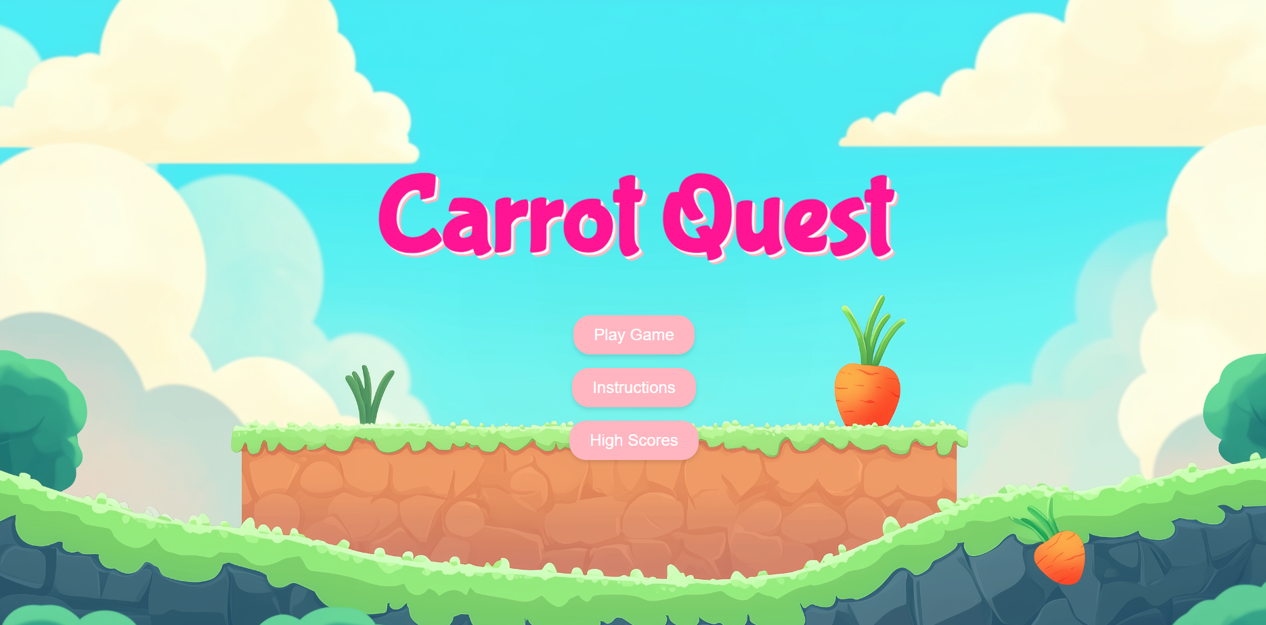

Conclusion

Contributions
- James M: Functional/ Non functional Requirements,UI, Image generation, Html, CSS, and Javascript

Glossary & References
Stable Diffusion: a text-to-image model developed by Stability AI.
Reference:
Automatic1111 et al. (2022). Stable Diffusion Web UI. GitHub repository. Retrieved from https://github.com/AUTOMATIC1111/stable-diffusion-webui

